Project Report Template

1.Introduction

1.1 Overview

I was selected the project Invitation creating in canva app. I can collected information related to the project.

1.2 Purpose

The project help me to enrich my knowledge apart from subject.

2. Problem Definition & Design Thinking

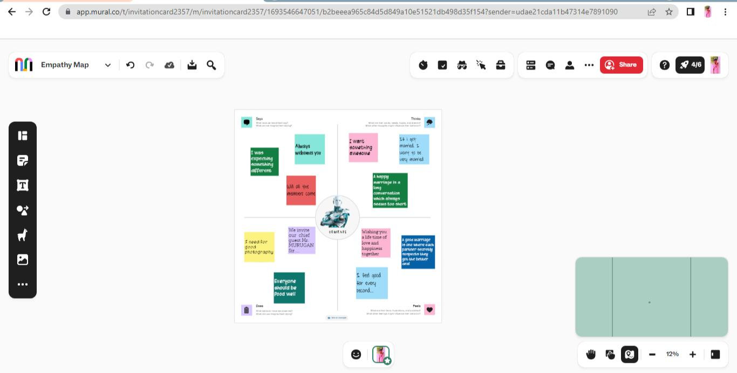 2.1 Empathy Map

2.2 Brainstorming Map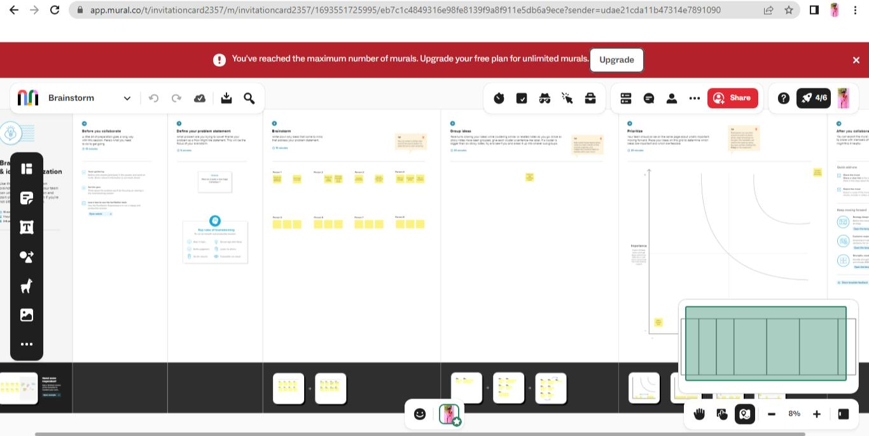

3.Result



4.Advantage

This application help us to create, enhance the skills in visual designing and also make us aware on the editing process and so on.

5.Disadvantage

The only think is network issue.

6.Application

By this app we can create a invitation Card by their own.

7.Conclusion

We were selected Marriage invitation in Canva application, And we learnt to apply color combination, designing, editing and so on. Through this project we gained new type of experience.This experience will help us in future.